VEHICLE SERVICE MANAGEMENT PLATFORM

INTRODUCTION:
The Vehicle Service Management Platform is a comprehensive digital solution designed to modernize and streamline the traditionally manual and fragmented operations of automotive service centers. By leveraging a robust MERN (MongoDB, Express, React, and Node.js) stack architecture, the system centralizes critical workflows including customer registration, real-time vehicle service tracking, and automated financial management through a strict, integrity-driven invoice control system. The platform bridges the communication gap between service providers and vehicle owners, replacing inefficient paper-based record-keeping with a secure, role-based environment that ensures operational transparency and data accuracy. Ultimately, this project aims to enhance the overall service lifecycle by optimizing resource allocation, reducing administrative overhead, and providing stakeholders with a seamless, data-driven interface for managing the end-to-end vehicle maintenance process.

SCENARIO-BASED CASE STUDY:
Scenario Title: Streamlining High-Volume Maintenance Operations for "Elite Auto Works"

1. The Challenge
A busy service center, "Elite Auto Works," struggles with paper-based tracking, leading to lost service history, duplicate billing errors, and customer frustration over a lack of updates. A customer, Mr. John Doe, brings in his vehicle for a complex engine diagnostic and routine maintenance.

2. The Solution (Platform Implementation)
- Step 1: Digital Intake & Registration: Upon arrival, the Front-Desk Manager registers Mr. John's vehicle on the platform. A digital Service Record is instantly created, capturing vehicle specifications, mileage, and specific customer complaints.
- Step 2: Role-Based Assignment: The Service Manager views the dashboard and assigns the task to Technician Sam, who specialized in engine diagnostics. Sam receives an instant notification on his dashboard.
- Step 3: Real-Time Progress Tracking: As Sam progresses, he updates the service status from "Pending" to "In Progress". Mr. John can log in to his own portal to see that his vehicle is currently being worked on, eliminating the need for phone inquiries.
- Step 4: Quality Control & Completion: Once the maintenance is finished, Sam marks the status as "Completed". The system performs a logic check to ensure all required fields are filled before allowing the status change.

3. The Outcome (Strict Financial Integrity)
- Automated Invoicing: The Front-Desk Manager attempts to generate an invoice. The platform's Strict Invoice Control logic ensures that an invoice can only be generated once the status is "Completed."
- Prevention of Duplicate Billing: The system blocks any attempt to generate a second invoice for the same service ID, preventing accounting errors.
- Payment & Closure: Mr. John receives a professional PDF invoice. Once payment is confirmed, the invoice status moves to "Paid", and the service record is archived in the vehicle's permanent digital history.

4. Key Benefits Demonstrated
- Operational Efficiency: Reduced manual entry and eliminated paper trails.
- Transparency: Real-time status updates improved customer trust.
- Financial Accuracy: Strict validation rules prevented revenue leakage and billing discrepancies.

SYSTEM REQUIREMENTS
1. Software Requirements
To ensure the seamless development, deployment, and operation of the Vehicle Service Management Platform, the following software environment is required:
- Operating System: Windows 10/11, macOS (Latest), or Linux (Ubuntu 20.04+).
- Environment: Node.js (v16.x or higher) and npm (v7.x or higher).
- Database: MongoDB (Local Community Server or MongoDB Atlas Cloud).
- Frontend Framework: React.js (v18+) with Vite/Create React App.
- State Management: Redux Toolkit.
- Backend Framework: Express.js (v4.x).
- API Testing Tools: Postman or Insomnia.
- Version Control: Git.
- Web Browser: Modern browsers with ES6+ support (Google Chrome, Mozilla Firefox, Microsoft Edge, or Safari).

2. Hardware Requirements
The platform is designed to be lightweight and responsive, but the following hardware specifications are recommended for optimal performance:
- Processor: Intel Core i3 (Minimum) / Intel Core i5 or AMD Ryzen 5 (Recommended).
- Memory (RAM): 4 GB (Minimum) / 8 GB or higher (Recommended for multitasking during development).
- Hard Disk Space: 500 MB of free space for the application code and local assets (excluding the size of the database and node_modules).
- Display: 1366 x 768 resolution (Minimum) / 1920 x 1080 (Recommended for the Admin Dashboard).
- Internet Connectivity: Stable broadband connection required for cloud database synchronization (MongoDB Atlas) and fetching external dependencies via npm.

PROJECT ARCHITECTURE
TECHNICAL ARCHITECTURE (MERN STACK)
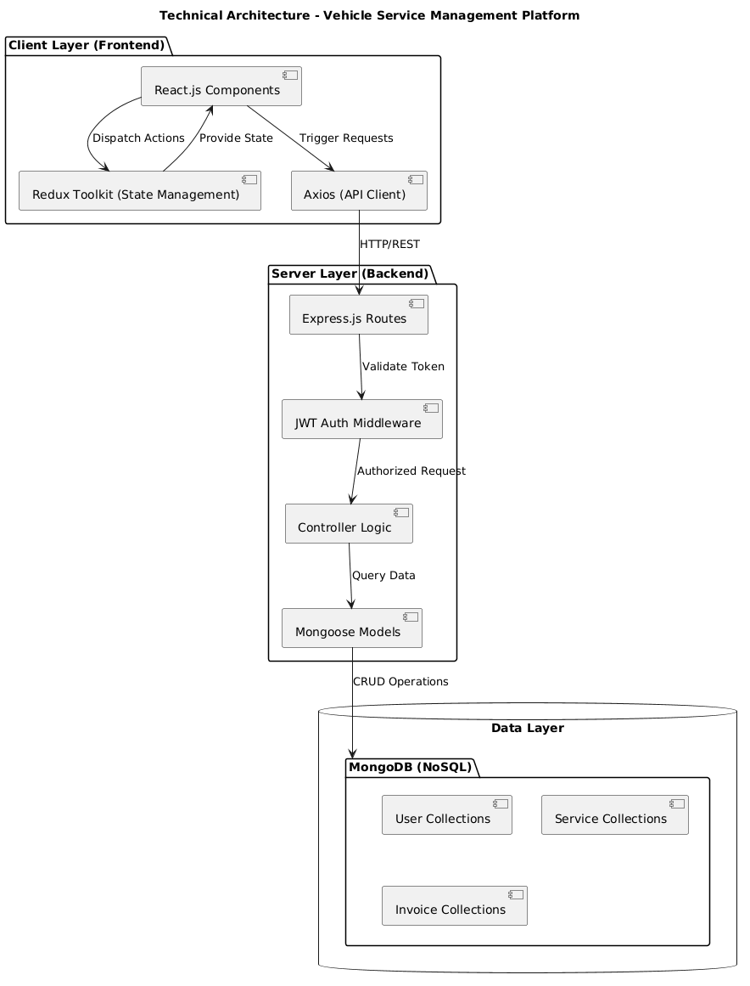
The platform follows a classic 3-Tier Client-Server Architecture, ensuring a clean separation of concerns between the user interface, business logic, and data storage.
- Presentation Layer (Frontend): Built with React.js, this layer manages the user interface and state. It uses Redux Toolkit for centralized state management (handling auth, services, and invoices) and Axios to communicate with the backend via RESTful APIs.
- Application Layer (Backend): Powered by Node.js and Express.js, this layer handles the business logic, route management, and request processing. It implements JWT (JSON Web Token) for secure authentication and Role-Based Access Control (RBAC) to restrict functionalities based on user types (Admin, Technician, etc.).
- Data Layer (Database): Uses MongoDB, a NoSQL database, to store documents in a flexible JSON-like format. Mongoose ODM is utilized to enforce schema validation and handle complex relationships between users, vehicles, and financial records.

ENTITY-RELATIONSHIP (ER) DIAGRAM
The following diagram illustrates the logical structure of the database and the relationships between core entities:
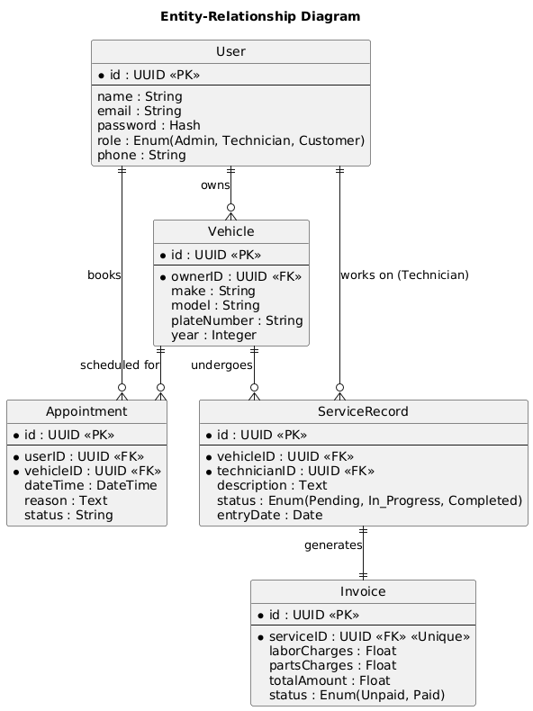
The provided ER Diagram illustrates the logical structure of the database and how different data entities interact within the Vehicle Service Management Platform. It ensures data integrity and defines the core business rules of the system.
1. Core Entities and Their Attributes
- User: Represents all stakeholders (Admin, Technician, Customer). It stores primary credentials and contact details. The role attribute is critical as it determines the user's permissions across the platform.
- Vehicle: Stores technical specifications of the vehicles brought for service. It is linked to an ownerID, identifying which user owns the car.
- Appointment: Manages the scheduling layer. It links a User (Customer) and a Vehicle to a specific dateTime and reason for the visit.

- ServiceRecord: This is the operational heart of the system. it tracks the actual work performed on a vehicle, the technician assigned to it, and the current progress status (Pending, In Progress, Completed).
- Invoice: The financial entity. It contains the breakdown of laborCharges and partsCharges. Crucially, it is linked to a serviceID to ensure every service performed is accounted for financially.

2. Key Relationships
- User ↔ Vehicle (One-to-Many): One user can register and own multiple vehicles in the system, but each vehicle is mapped to one primary owner.
- User ↔ Appointment (One-to-Many): A customer can book several appointments over time for different maintenance needs.
- User ↔ ServiceRecord (One-to-Many): This relationship defines the Technician's role. A single technician can be assigned to multiple service records, managing their work queue through the dashboard.
- Vehicle ↔ ServiceRecord (One-to-Many): This allows the platform to maintain a complete "Service History" for a vehicle. One vehicle will undergo many service sessions over its lifetime.
- ServiceRecord ↔ Invoice (One-to-One): This represents the Strict Financial Integrity of the system. Each unique service record generates exactly one unique invoice. The "Unique" constraint on serviceID in the Invoice entity prevents duplicate billing and ensures financial transparency.

3. Cardinality and Constraints
The diagram uses "Crow's Foot" notation to show cardinality (e.g., ||--o{ indicates one-to-many). Key constraints like Primary Keys (PK) for unique identification and Foreign Keys (FK) for establishing links between tables are used to maintain a relational integrity that prevents data loss or orphaned records.

KEY FEATURES:
The platform is designed with a focus on operational efficiency, financial transparency, and user convenience. Below are the core features that define the system:
- 1. Multi-Role Specialized Dashboards: The system provides distinct, tailored interfaces for Administrators, Service Managers, Technicians, and Customers. Each user sees only the data and tools relevant to their specific role, ensuring a clutter-free and secure experience.
- 2. Real-Time Service Tracking: From the moment a vehicle enters the workshop to its final delivery, the platform tracks its progress. Users can see real-time status updates (e.g., Pending → In Progress → Completed), providing transparency for both the workshop team and the vehicle owner.
- 3. Strict Invoice Control System: To ensure financial integrity, the platform implements a "strict" invoicing logic. Invoices can only be generated once a service is marked as "Completed." The system also prevents the generation of duplicate invoices for the same service record, eliminating billing errors.
- 4. Automated Appointment Management: Customers can book service slots online, reducing the need for phone calls and manual scheduling. Managers can review these appointments on a centralized calendar and assign them to available technicians with a single click.
- 5. Secure Role-Based Access Control (RBAC): Security is maintained through JSON Web Tokens (JWT). The platform ensures that sensitive actions—such as deleting a user or generating a financial report—are restricted only to authorized roles like the Admin or Manager.
- 6. Comprehensive Vehicle Service History: The platform maintains a permanent digital record for every vehicle registered. This includes past repairs, parts replaced, and labor costs, allowing both the service center and the owner to track the long-term health and maintenance costs of the vehicle.
- 7. Responsive and Modern UI/UX: Built with React and modern CSS, the platform features a responsive design that works seamlessly across desktops, tablets, and smartphones, allowing technicians to update statuses on the go and customers to check their vehicle from anywhere.
- 8. Dynamic Financial Reporting: The system automatically calculates labor and parts costs to generate professional PDF invoices. For administrators, it provides an overview of revenue and workshop productivity, aiding in data-driven decision-making.

ROLES AND RESPONSIBILITIES:
Admin:
The System Administrator serves as the primary controller of the platform, responsible for the high-level management of the entire ecosystem. Their duties include onboarding and managing user accounts, overseeing system-wide security protocols, and ensuring the integrity of the database. The Administrator has the unique authority to monitor performance analytics across all branches, manage system configurations, and troubleshoot any critical operational issues to ensure 24/7 platform availability.

Service Center:
The Service Center acts as the operational bridge between customers and the technical team. Their responsibility begins with the review and approval of service appointments and extends to the strategic assignment of tasks to Technicians based on workload and expertise. Crucially, the Manager oversees the financial workflow, utilizing the platform's strict controls to generate accurate invoices only after verifying that the maintenance work has been fully completed and documented.

Technician:
The Technician is responsible for the hands-on execution of vehicle maintenance and the real-time reporting of service progress. Each Technician manages a personal dashboard where they can view assigned tasks, update the status of a vehicle from "Pending" to "In Progress" or "Completed," and log technical details regarding parts used or repairs made. Their primary responsibility is to provide accurate data entry that feeds directly into the customer’s tracking portal and the final billing process.

Customer:
The Customer (Vehicle Owner) is the end-user of the service who interacts with the platform to manage their vehicle's lifecycle. Their responsibilities include maintaining an updated profile, registering vehicle details, and initiating service requests through the booking module. Once a service is underway, they are responsible for monitoring updates through their portal and, upon completion, reviewing and settling the generated invoices to finalize the transaction.

User Flow:
The customer flow focuses on self-service management, from vehicle registration to tracking and payment.
Flow: Login → Add Vehicle → Book Appointment → Track Live Status → View/Download Invoice.
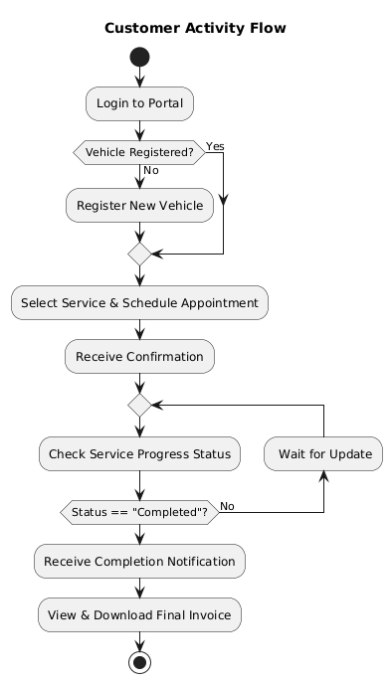
Technician Flow:
The technician flow is centered around task execution and real-time data updates.
Flow: Login → View Assigned Tasks → Change Status to "In Progress" → Perform Service → Mark as "Completed" → Add Service Notes.
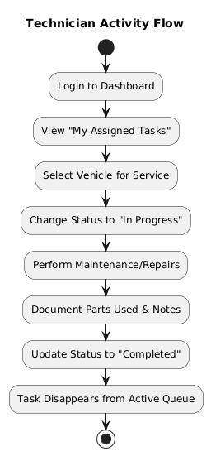

Service Manager Workflow
The manager flow focuses on coordination, quality control, and financial finalization.
Flow: Login → Review Appointments → Assign Technician → Monitor Workshop Workload → Generate Invoice (Once status is "Completed") → Verify Payment.
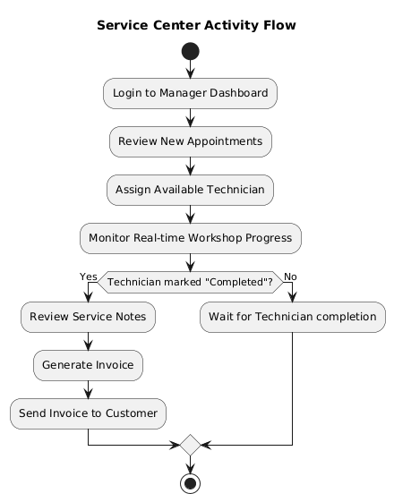

System Admin Workflow
The admin flow is focused on platform governance and high-level management.
Flow: Login → User Management (CRUD) → System Health Monitoring → View Analytics Reports → Manage Service Categories.

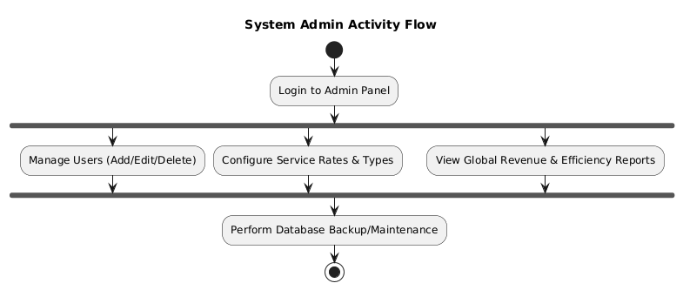

MVC PATTERN:
The Vehicle Service Management Platform is built using the Model-View-Controller (MVC) design pattern. This architecture separates the application into three interconnected components, allowing for efficient code management, scalability, and independent development of the frontend and backend.
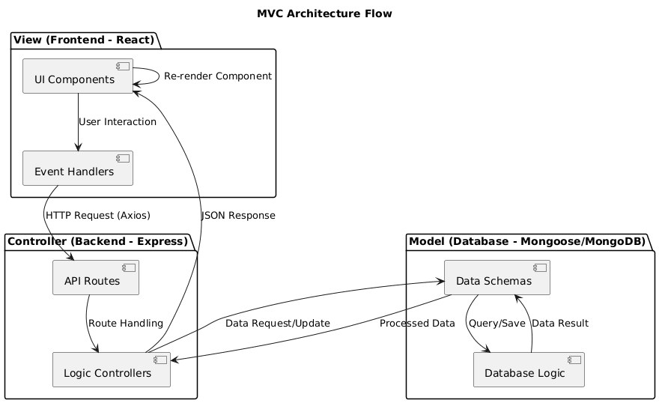

1. The Model Layer
The Model represents the data structure and the business logic of the application. In this project, the Model is implemented using Mongoose Schemas and MongoDB.
- Responsibility: It defines the shape of the data (e.g., User, Vehicle, Invoice), handles database queries (CRUD), and enforces data validation rules (e.g., ensuring a service is "Completed" before an invoice can be generated).
- Key Files: userModel.js, invoiceModel.js, appointmentModel.js.

2. The View Layer
The View is the user interface of the application. Since this is a MERN stack project, the View is built entirely with React.js.
- Responsibility: It is responsible for rendering data provided by the Controller into a readable format for the user. It captures user inputs (like booking a service) and sends them back to the Controller via API calls.
- Key Files: AdminDashboard.jsx, CustomerDashboard.jsx, BookServicePage.jsx.

3. The Controller Layer
The Controller acts as the intermediary between the Model and the View. In this project, it is implemented using Express.js route handlers.
- Responsibility: It receives requests from the View (Frontend), processes them (often involving authentication and validation via Middleware), interacts with the Model to fetch or update data, and finally sends a JSON response back to the View.
- Key Files: invoiceController.js, appointmentController.js, userController.js.

ADVANTAGES OF USING MVC IN THIS PROJECT:
Implementing the Model-View-Controller (MVC) architecture provides several strategic benefits for the Vehicle Service Management Platform, particularly in terms of long-term stability and development efficiency.
1. Parallel Development: By decoupling the View (React Frontend) from the Controller/Model (Node.js Backend), different developers can work simultaneously. For example, one developer can refine the "Invoice Generation" logic in the backend while another designs the "Technician Dashboard" UI, without causing merge conflicts or blocking each other’s progress.

2. Enhanced Maintainability: Since the business logic (Controller) is separate from the user interface (View), updates are much easier to manage. If the service center decides to change its tax calculation for invoices, we only need to update a single function in the invoiceController.js (Model/Controller) without needing to touch any of the CSS or React components in the frontend.

3. Scalability and Flexibility: The MVC pattern makes it simple to scale the application. If the business grows and needs a new role—such as an "Inventory Manager"—we can easily add a new inventoryModel.js and inventoryController.js without disrupting the existing flow of Customers and Technicians.

4. Code Reusability: The backend (Controller and Model) acts as a standalone API. This means that if the platform expands to include a Mobile App in the future, the same backend logic and database can be reused to serve data to the mobile interface, significantly reducing future development costs.

5. Streamlined Debugging: The clear separation of concerns allows for faster troubleshooting. If a user reports that a "Status Badge" is not updating, we can instantly isolate whether the issue is a data-fetching error in the Controller, a schema error in the Model, or a simple rendering bug in the View.

6. Strict Data Integrity: Centralizing the logic in the Controller ensures that our "Strict Invoice Control" rules are always enforced. Because the View cannot interact with the Database directly, the Controller acts as a gatekeeper, ensuring that an invoice can only be created when the Service Model satisfies the "Completed" status, regardless of how the request is initiated.

PROJECT SETUP AND CONFIGURATION
This section outlines the steps required to set up the development environment and configure the Vehicle Service Management Platform for local execution.
1. Environment Prerequisites
Before installation, ensure the following are installed on your system:
- Node.js (v16+) and npm (Node Package Manager).
- MongoDB: Either a local MongoDB Community Server instance or a MongoDB Atlas cloud connection string.
- Git: For cloning the repository.
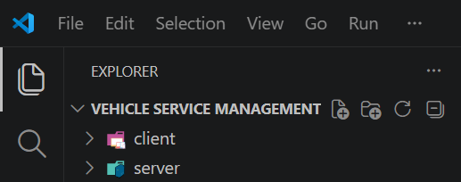
2. Server-Side Configuration
- Navigate to the Server Directory:
bash
cd server
- Install Dependencies:
bash
npm install
- Environment Variables (.env): Create a .env file in the root of the server directory and configure the following keys:
env
PORT = 5000
MONGO_URI = your_mongodb_connection_string
JWT_SECRET = your_complex_secret_key
NODE_ENV = development
- Database Seeding (Optional): If the project includes a seed script (e.g., seedAdmin.js), run it to create the initial admin account:

bash
node utils/seedAdmin.js

3. Client-Side Configuration
- Navigate to the Client Directory:
bash
cd client
- Install Dependencies:
bash
npm install
- API Base URL Configuration: Ensure the Axios base configuration (usually in src/utils/api.js or package.json proxy) points to the server port:
  - Default: http://localhost:5000/api

4. Running the Application
To run the full stack, you must start both the backend and frontend servers.
- Start the Backend: Inside the server folder, run:
bash
npm run dev
(The server will typically start on port 5000 with nodemon for auto-restarts.)
- Start the Frontend: Inside the client folder, run:
bash
npm run dev # For Vite
OR
npm start # For Create React App
(The application will be accessible at http://localhost:5173 or http://localhost:3000.)

5. Project Folder Structure
A brief overview of the organized codebase:
- /server: Contains Express logic, Mongoose models, and Middleware.
- /client/src/components: Reusable UI elements (Table, Sidebar, Navbar).
- /client/src/pages: Individual route-based views (Dashboards, Booking).
- /client/src/redux: Redux Toolkit slices for global state management.

BACKEND DEVELOPMENT:
Backend Reference Video:
https://drive.google.com/file/d/1yUTRfuDMa-TH_C1AEpMR8KO8pekW7-Di/view?usp=drive_link
Backend Structure:
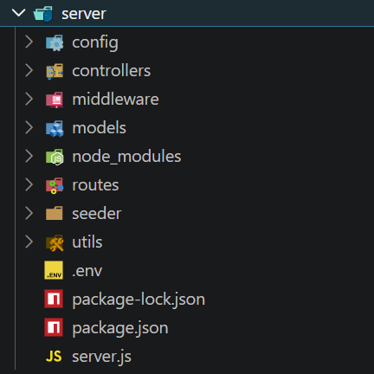

1. Controllers
Controllers contain the core logic for every action in the system. They process incoming data from the request, interact with the Models, and send back appropriate responses.
- Authentication Controller: Manages user registration, login, and token generation.
- Service Controller: Handles the lifecycle of a vehicle service (entry, status updates, completion).
- Invoice Controller: Contains the strict logic for generating financial records and preventing duplicate billing.

2. Database (DB Configuration)
The database layer is managed through Mongoose, an Object Data Modeling (ODM) library for MongoDB.
- Connection Logic: A dedicated configuration file (e.g., db.js) manages the connection to the MongoDB cluster using environment-protected URIs.
- Indexing: Key fields like email in Users and serviceID in Invoices are indexed for high-speed retrieval.
- Scalability: The NoSQL nature of MongoDB allows for flexible storage of vehicle history and technical logs without rigid table constraints.

3. Middleware
Middleware functions act as "gatekeepers" that process requests before they reach the Controllers.
- Auth Middleware: Validates JSON Web Tokens (JWT) to ensure that only logged-in users can access the system.
- Role Middleware: Implements Role-Based Access Control (RBAC), checking if the authenticated user has the permissions (e.g., "Admin" or "Technician") to perform a specific action.
- Error Middleware: A centralized error-handling function that catches any system crashes and sends a user-friendly error message back to the frontend.

4. Models
Models define the structure of the data stored in the database. Each model ensures that data is consistent and valid.
- User Model: Stores credentials, contact info, and roles.
- Vehicle Model: Captures make, model, year, and owner linkage.
- Appointment Model: Manages scheduling data and reason for service.
- Invoice Model: Stores financial breakdowns, including labor, parts, and payment status.

5. Routes
Routes define the entry points (API Endpoints) of the backend. They map specific URLs to their corresponding Controller functions.
- Clean Organization: Routes are grouped logically (e.g., /api/users, /api/services, /api/invoices).
- Security Integration: Protection is applied at the route level using middleware (e.g., router.post('/generate', auth, isManager, generateInvoice)).
- RESTful Design: The platform follows standard REST principles, using GET for fetching data, POST for creating, PUT for updating, and DELETE for removal.

DATABASE DEVELOPMENT
The database layer is the foundation of the Vehicle Service Management Platform, ensuring that all user data, service histories, and financial records are stored securely and retrieved efficiently.
1. Configure MongoDB
For this project, MongoDB was selected for its high performance and document-oriented flexibility, which is ideal for storing varied vehicle data and service logs.
- Cluster Setup: The database is hosted on MongoDB Atlas (Cloud) to ensure high availability and automatic backups.
- Security: Access is restricted using IP Whitelisting and strict database user authentication.
- Environment Isolation: The connection string is never hardcoded; it is stored in an encrypted .env file to prevent unauthorized access to the data layer.

2. Create Database Connection
The connection between the Node.js server and MongoDB is established using the Mongoose ODM. This connection is managed by a centralized utility function:
- Asynchronous Initialization: The connection uses async/await to ensure the server only starts once a successful handshake with the database is confirmed.
- Error Handling: The connection logic includes try-catch blocks to log descriptive errors and terminate the process if the database is unreachable, preventing the app from running in an unstable state.
- Optimization: Connection pooling and timeout settings are configured to handle multiple concurrent user requests efficiently.

3. Create Schemas
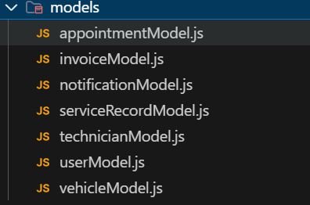
Mongoose Schemas are utilized to enforce a structured format on the otherwise schemaless MongoDB documents. This ensures data integrity across the platform.
- Data Validation: Schemas define data types (String, Number, Date), set required fields, and use unique constraints (e.g., for user emails and vehicle plate numbers).
- Relationship Management: Schemas use ObjectIds and References (refs) to link documents together. For example, the VehicleSchema contains an ownerID that points to a specific document in the User collection.
- Timestamps: All schemas automatically include createdAt and updatedAt timestamps, which are critical for tracking when a vehicle was admitted and when a service was completed.
- Middleware: Pre-save hooks are used within schemas for tasks like password hashing, ensuring security is handled at the data definition level.

FRONT END DEVELOPMENT:
FRONTEND REFERENCE VIDEO:
https://drive.google.com/file/d/1yUTRfuDMa-TH_C1AEpMR8KO8pekW7-Di/view?usp=drive_link

FRONTEND STRUCTURE:
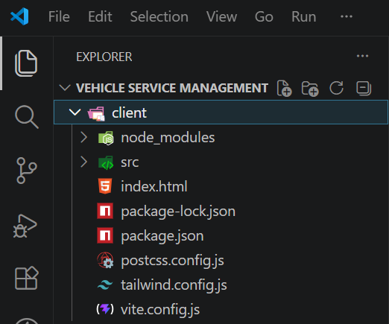
The frontend of the Vehicle Service Management Platform is built with React.js, following a modular and scalable directory structure. This organization ensures that components are reusable, the state is predictable, and the codebase remains easy to navigate as the project grows.
Core Directory Organization
- /components: This directory contains reusable UI elements. It is further divided into:
  - Common: Generic components like Table.jsx, StatusBadge.jsx, and Card.jsx that are used across multiple pages.
  - Layout: Structural components like Navbar.jsx and Sidebar.jsx that define the overall application frame.
- /pages: These are high-level components mapped directly to application routes. Each page (e.g., AdminDashboard.jsx, BookServicePage.jsx, RegisterPage.jsx) acts as a container that orchestrates multiple components and handles page-specific logic.
- /redux: The centralized state management layer. It contains:
  - Slices: Individual logic files (e.g., authSlice.js, invoiceSlice.js) that handle specific data domains and their corresponding actions.
  - Store: The main configuration file that combines all slices into a single global state object.
- /utils: A utility folder for non-UI logic.
  - API Configuration: Centralized Axios instance with interceptors for attaching JWT tokens to outgoing requests.
  - Icons: Centralized SVG or library imports (like Lucide-React) for consistent visual language.
- /assets: Stores static files such as the project’s main index.css, images, and branding assets.
Architectural Benefits
- Component Reusability: By separating "Common" components, we avoid duplicating code for similar elements like data tables or input fields.
- Scalable State: Using Redux Slices ensures that data (like vehicle lists or service statuses) is updated in real-time across all pages without complex prop-drilling.
- Clean Routing: The modular structure allows App.jsx to serve as a clean roadmap of the application's URL structure, making it easy to add or protect new routes using role-based guards.

OUTPUT SCREENSHOTS:
Landing Page:
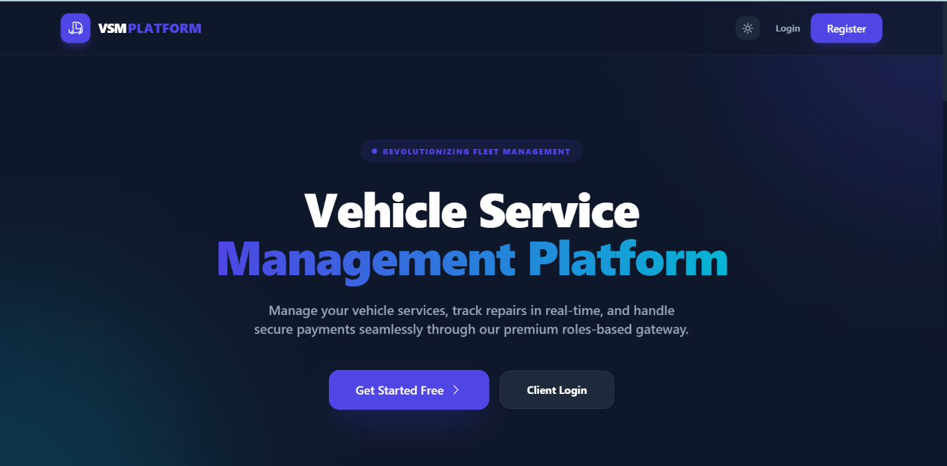

Register Page:
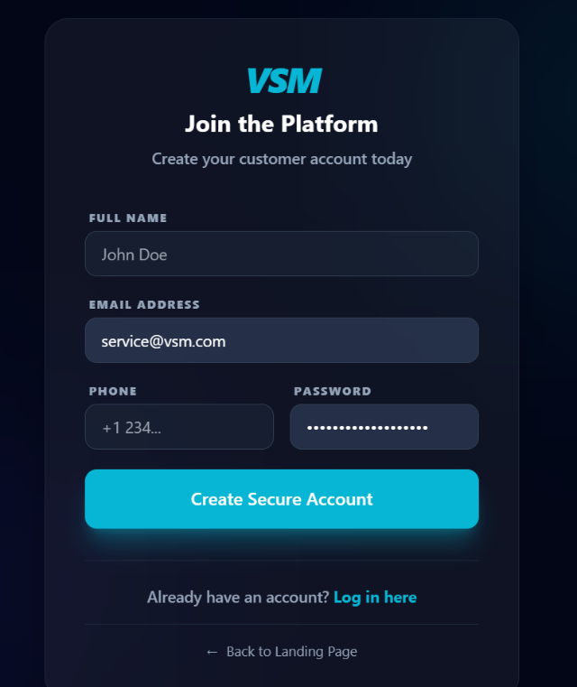

Login Page:
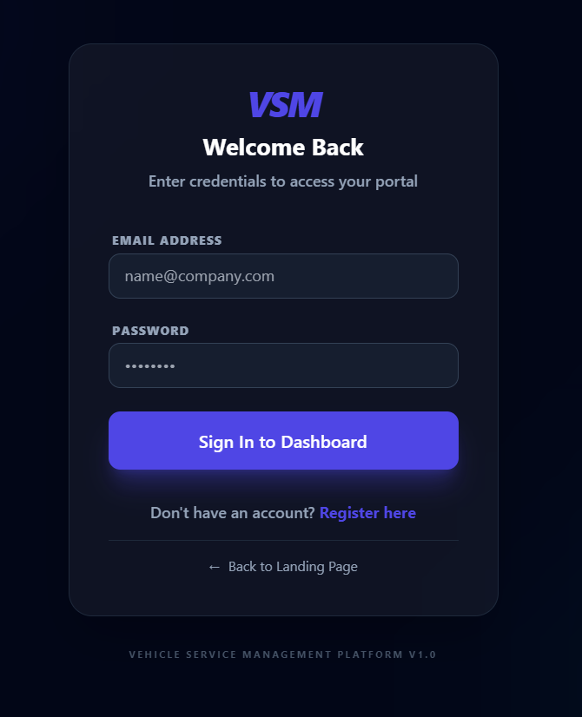

User Portal:
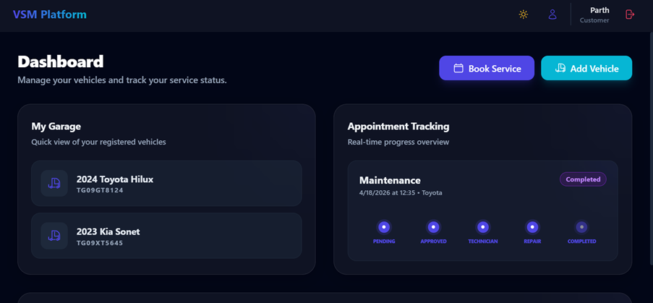

Vehicle Registration:
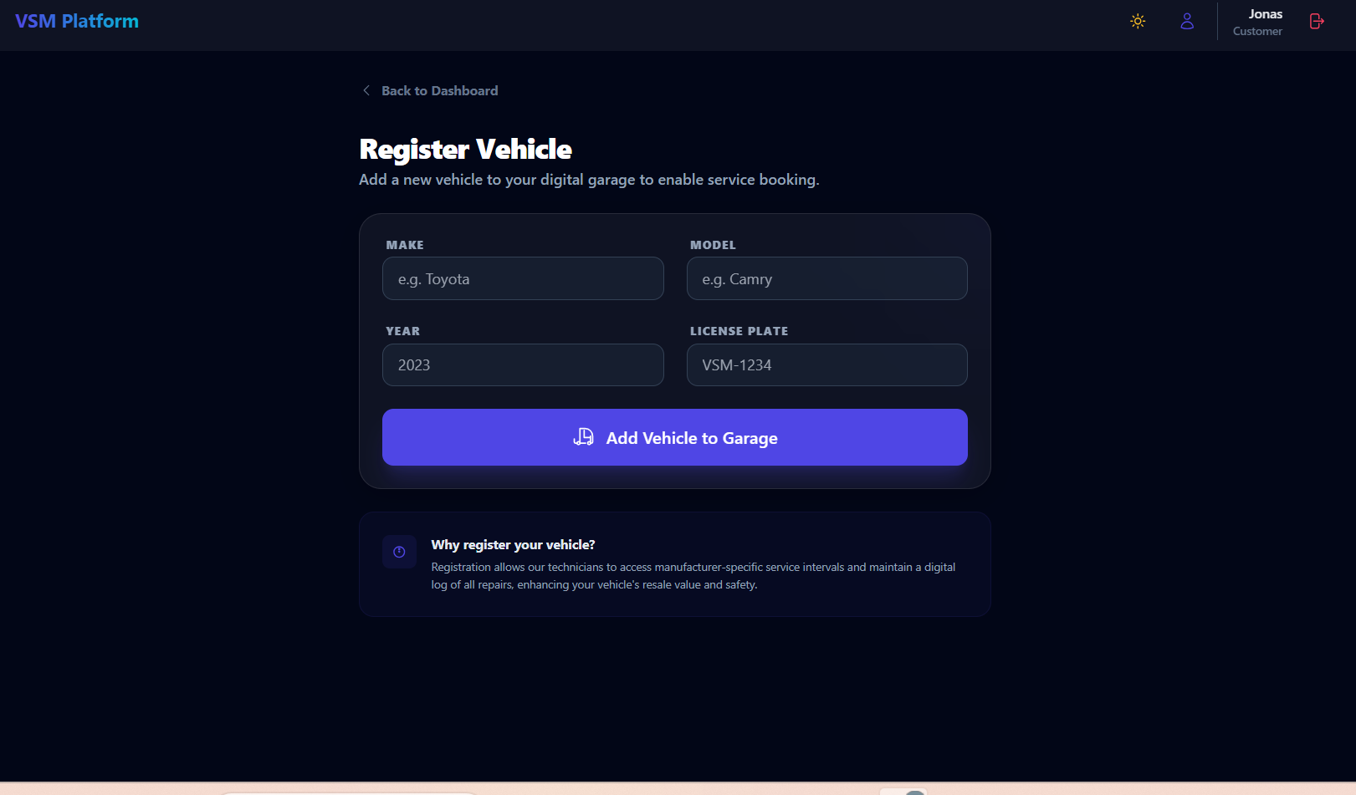
Service Booking:
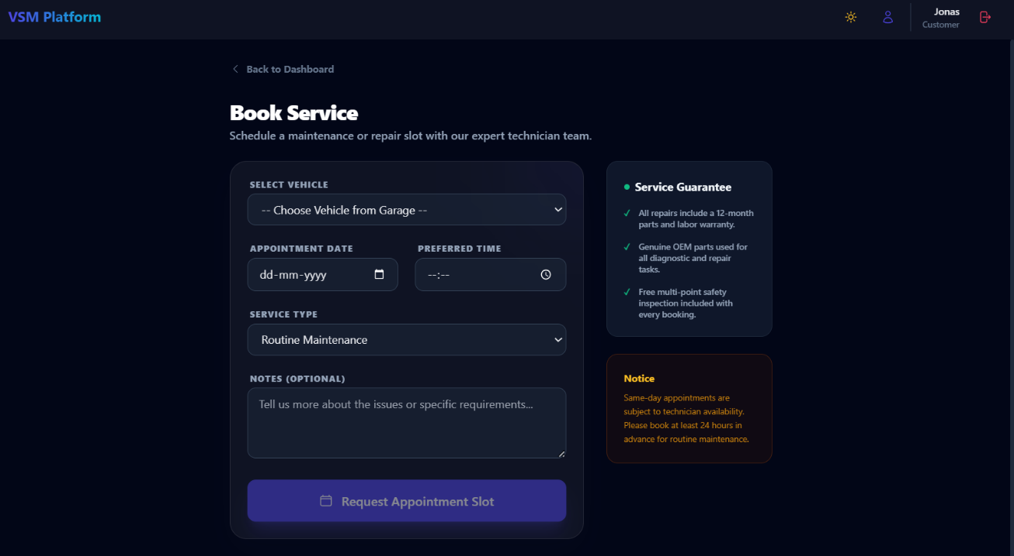

Technician Portal:
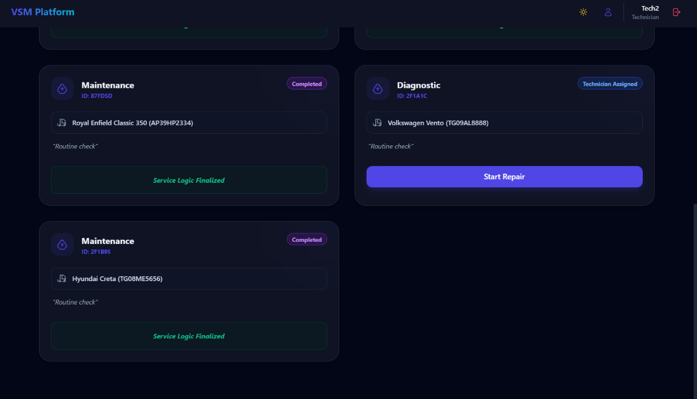
Service Centre Portal:
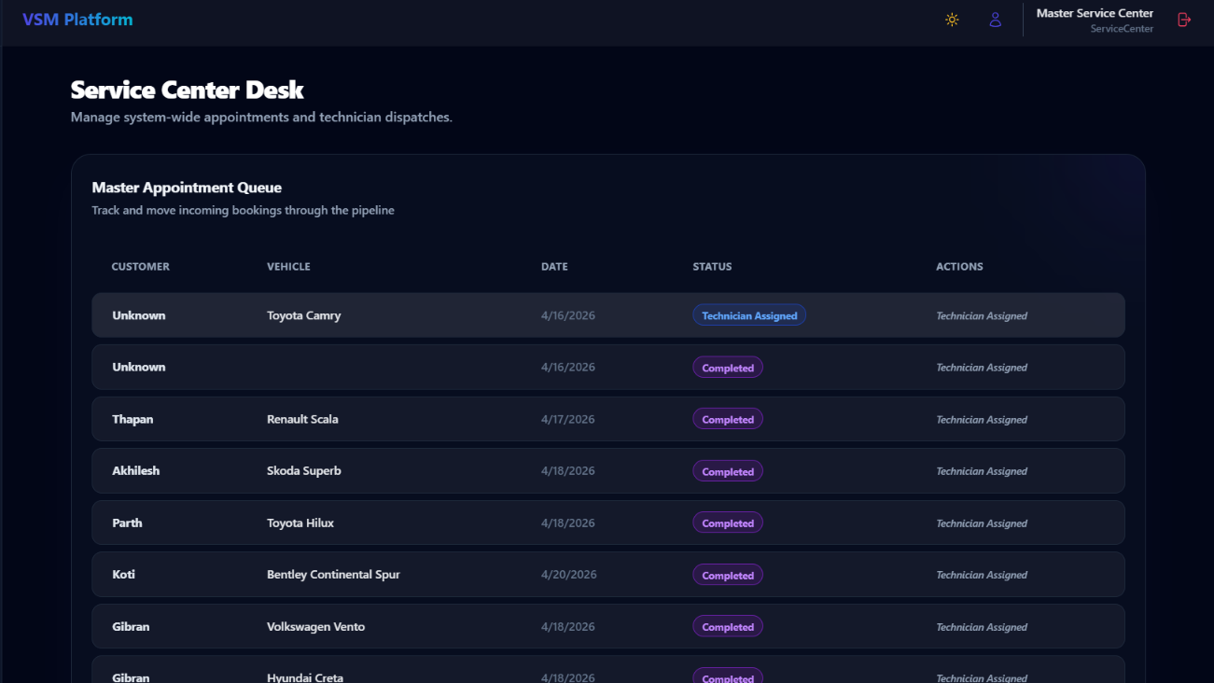

Invoice Generation:
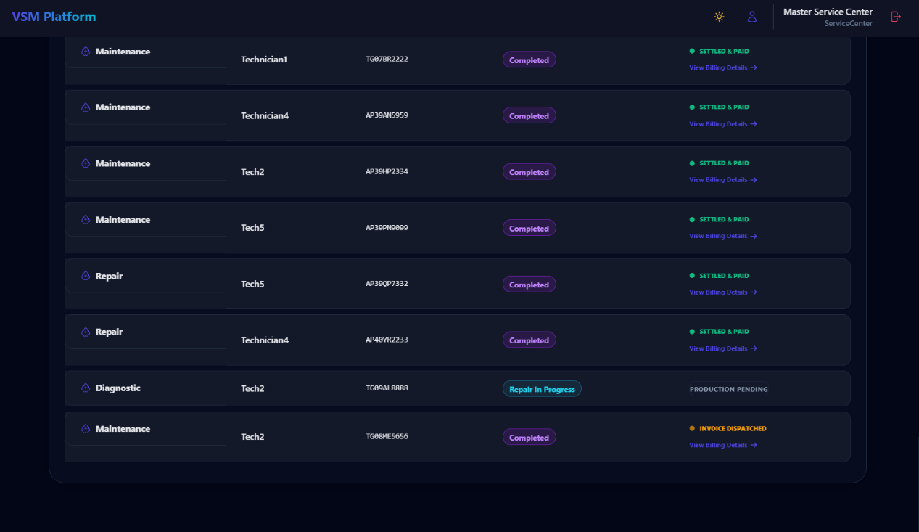
Payment Section:
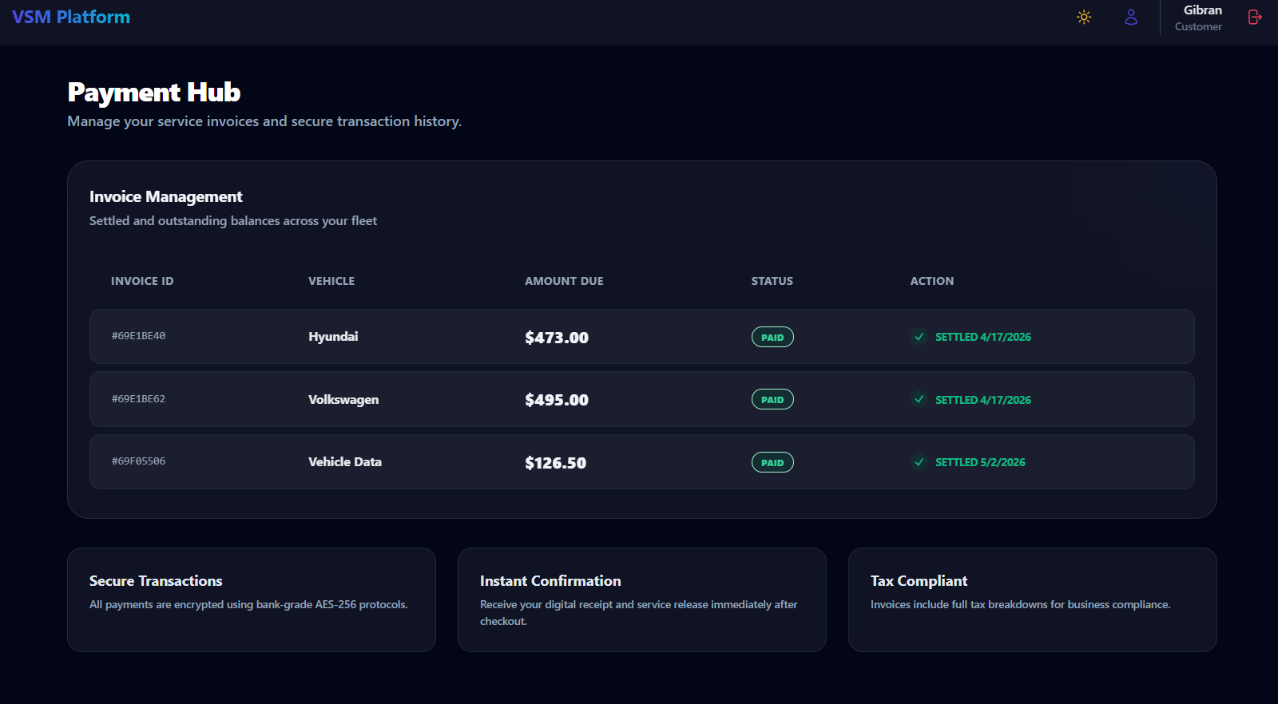

Admin Portal:
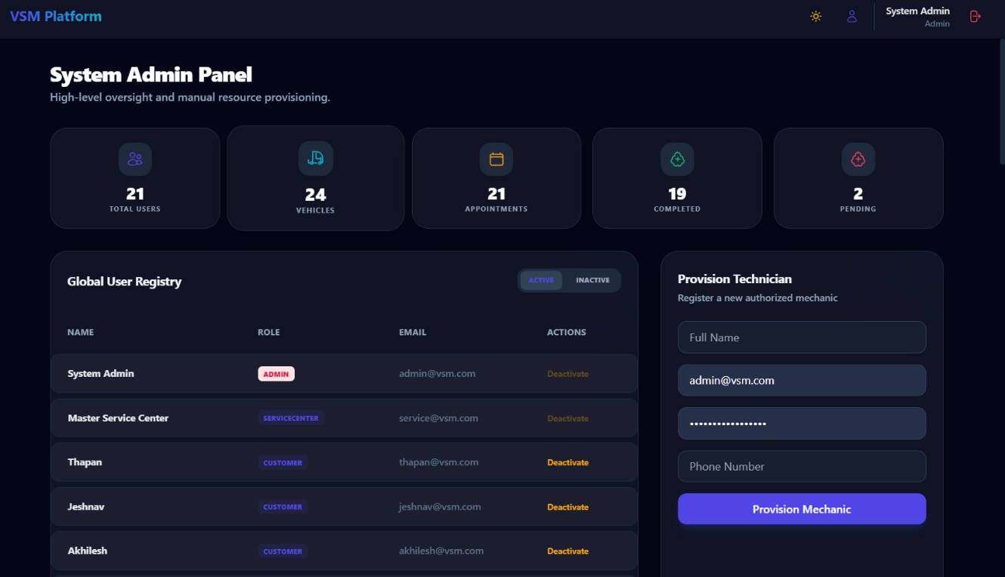

REPOSITORY LINK:
Github:
https://github.com/Thapan6/Vehicle-Service-Management

